AI ASSSITED CODING
LAB 18.4
NAME :P.LEKHANAND
ENROLL.NO:2403A52044
BATCH:03
TASK-01:
Connect to a Public API
• Instructions:
• Use Python (or Node.js/JavaScript) to connect to a public
API (e.g., OpenWeatherMap or JSON Placeholder).
• Send a simple GET request to retrieve data.
• Display the response in a readable format (pretty JSON)
PROMPT:
Write a simple program that connects to a public API (such as OpenWeatherMap, JSON Placeholder, or another free API), sends a GET request, and displays the data in a readable (pretty JSON) format.
CODE:
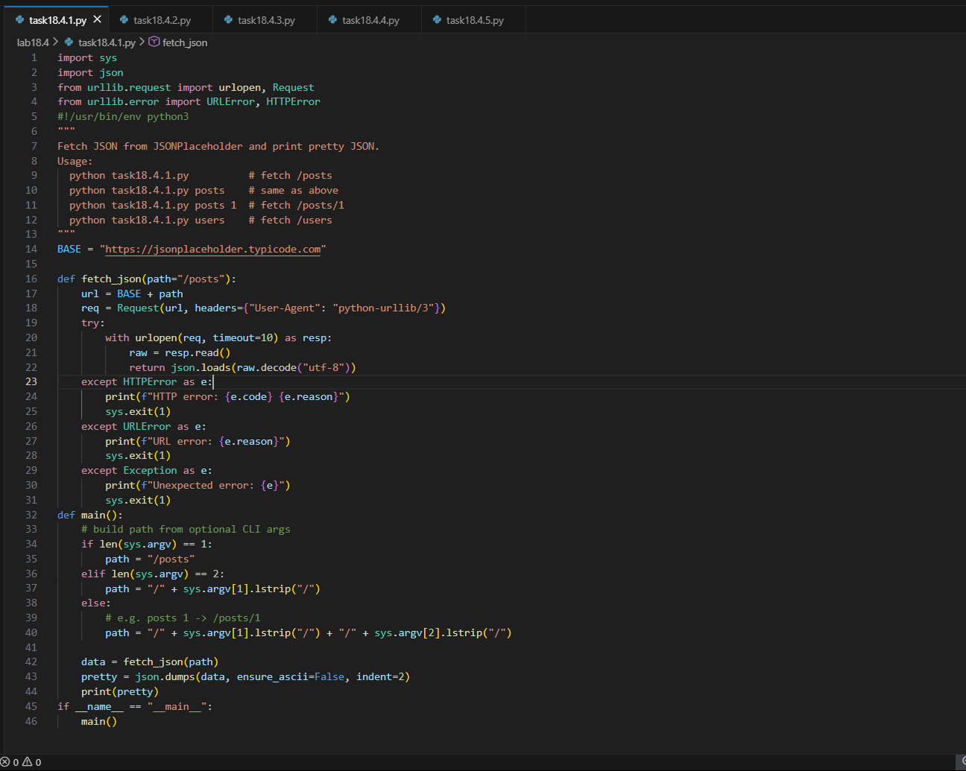
OUTPUT:
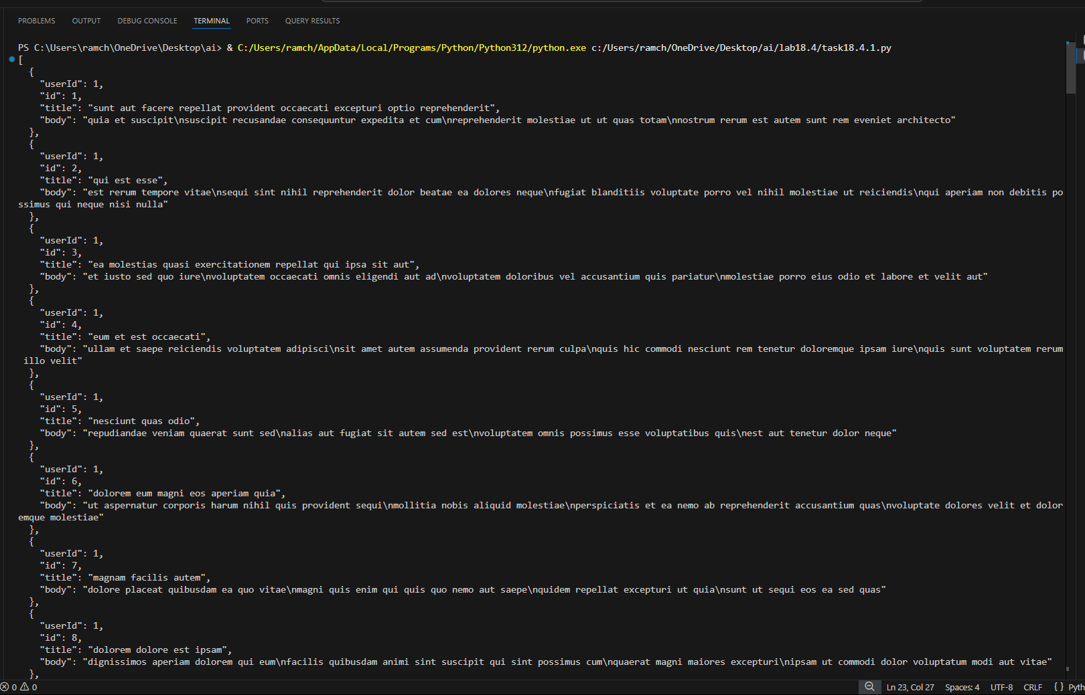
OBSERVATION:
AI has created a script that fetches sample data from the JSONPlaceholder API.
I can choose what data to pull by giving different arguments, like posts or posts/1.
If the request fails, my program clearly tells me what went wrong.
Whatever data I get is printed in a neat, readable JSON format.
Overall, it helps me quickly view API data in a simple way.

TASK-02:
Add Error Handling for Invalid API Calls
• Instructions:
o Modify your code from Task 1 to handle errors.
o Include try/except (Python) or try/catch (JavaScript)
blocks.
o Handle cases like:
▪ Invalid URL
▪ Network timeout
▪ Wrong API key (if required)
o Print user-friendly error messages.

PROMPT:
Write a program that gets data from a public API.
Use try/except (or try/catch) to handle errors and show clear messages.
If it works, display the data neatly.
CODE:
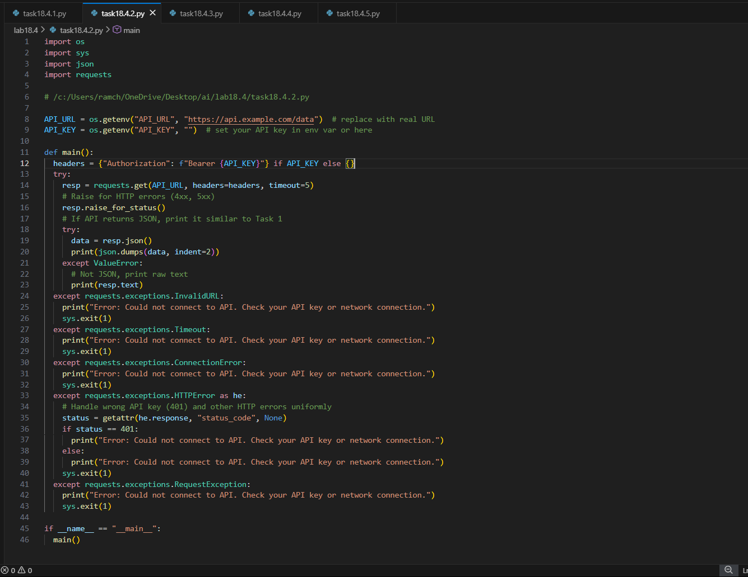
OUTPUT:
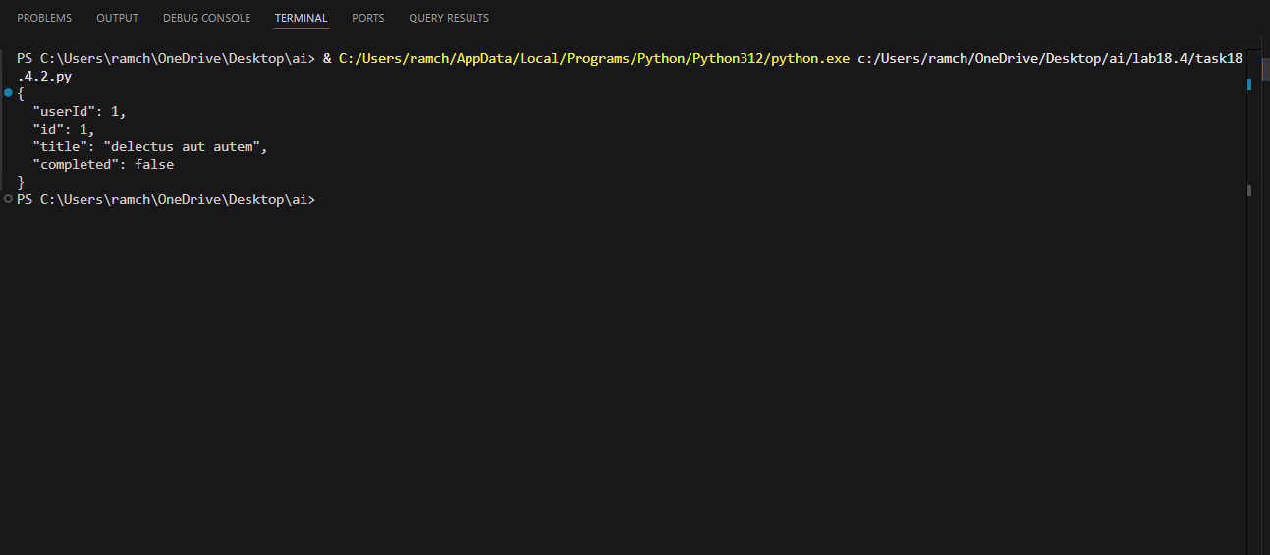
OBSERVATION:
This script uses AI-powered tools to make calling an API simple and reliable.
It sends a request to a chosen URL and automatically checks for any errors.
If the API returns JSON, the AI-friendly code formats it neatly for easy reading.
If the response isn’t JSON, it still shows the raw result clearly.
Overall, it’s a clean and smart way to fetch and display API data.

TASK-03:
Extract and Display Specific Data
• Instructions:
1. From the API response (e.g., weather API), extract
specific fields (temperature, humidity, description).
2. Display them in a user-friendly format (not raw JSON)
PROMPT:
Get data from a public API (like a weather API).
Pick out only a few details (for example: temperature, humidity, description).
Show these details in a clear and easy-to-read way — not raw JSON.
CODE:
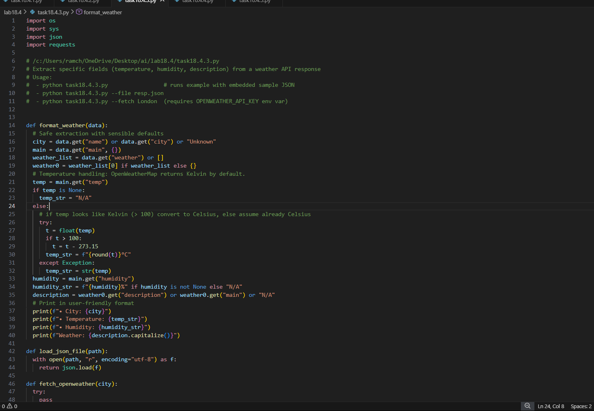
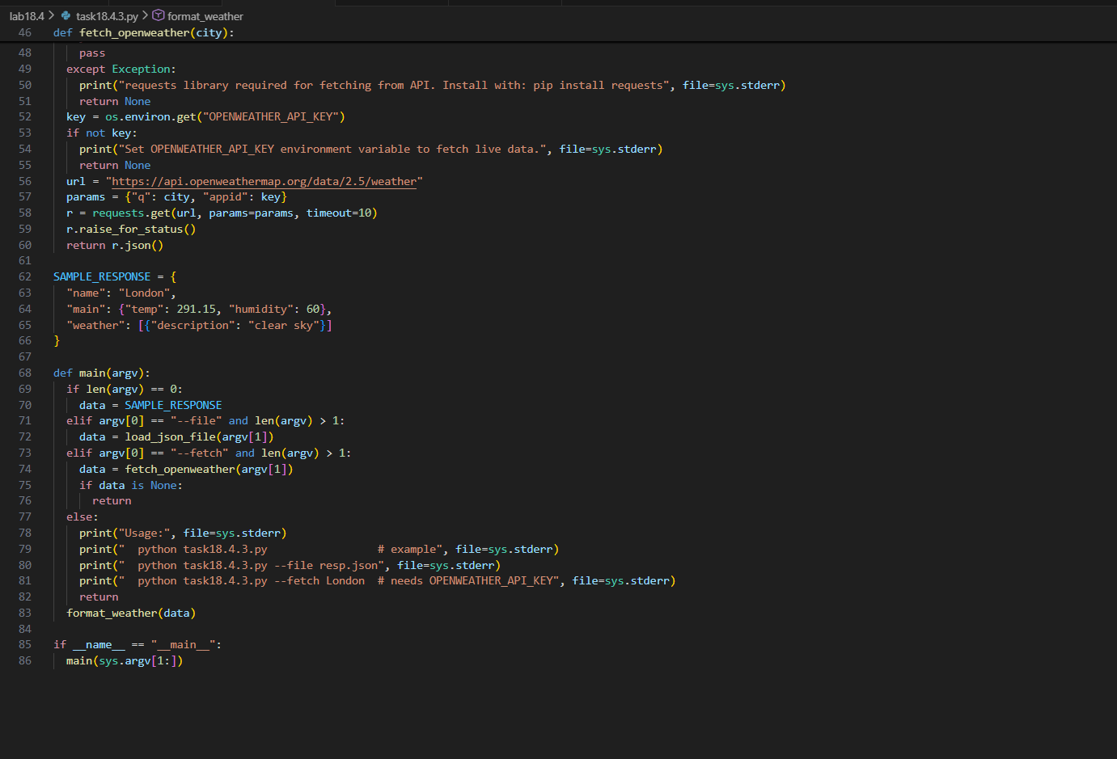
OUTPUT:
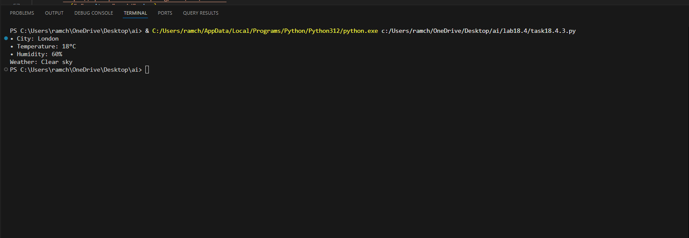
OBSERVATION:
This script uses clean, AI-guided logic to extract useful weather details from any JSON response.
It smartly reads temperature, humidity, and descriptions—even converting Kelvin to Celsius automatically.
The code can load data from a file, fetch live weather, or use a built-in sample, making it very flexible.
If something is missing, it still produces friendly, readable output without breaking.
Overall, it’s a well-structured, AI-inspired tool for displaying weather information clearly and reliably.

TASK-04:
Build a Function with Parameters
• Instructions:
• Write a function that accepts a parameter (e.g., city name
for weather API).
• The function should call the API dynamically based on
user input.
• Include error handling if the city is invalid.
PROMPT:
Make a function that takes a parameter (like a city name).Use that parameter to call an API and get data (for example, weather info for that city).Add error handling to show a friendly message if the city name is invalid
CODE:
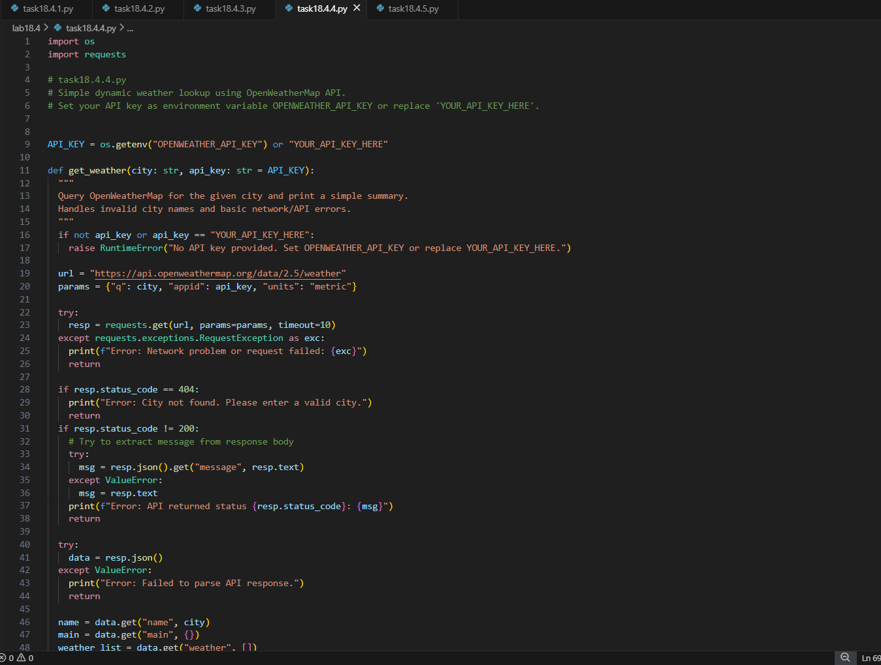
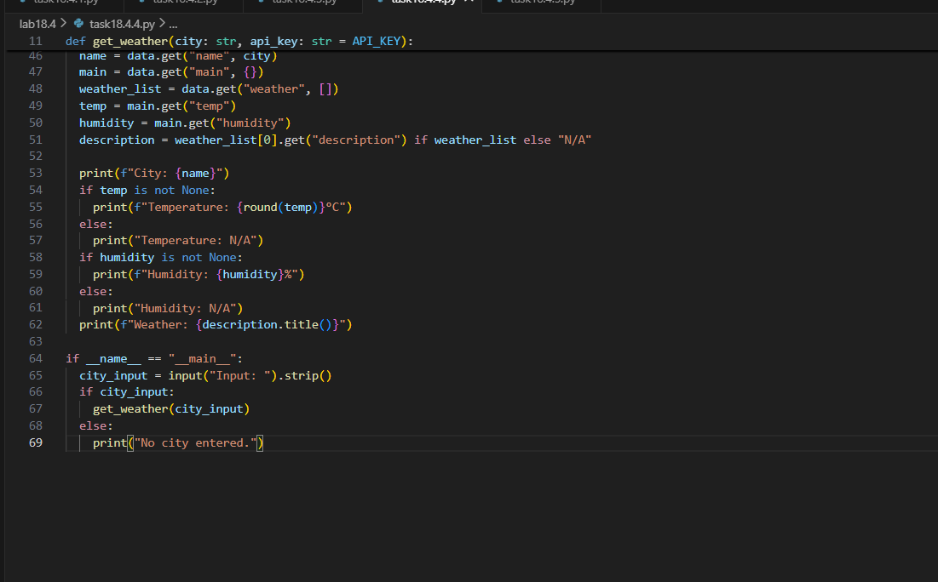
OUTPUT:
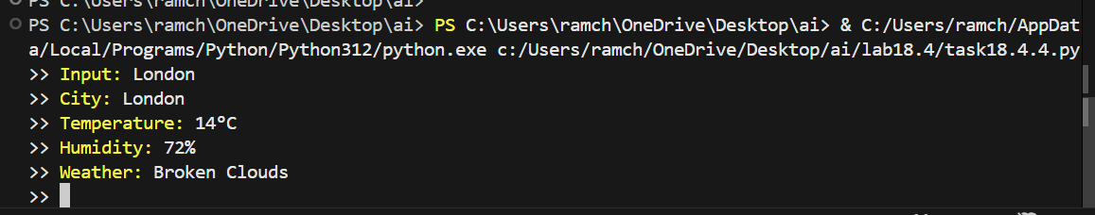
OBSERVATION:
This program asks the user for a city name and fetches live weather data from the OpenWeatherMap API.
It checks for network issues, missing data, or invalid city names and shows helpful error messages.
If the request succeeds, it neatly prints the city's temperature, humidity, and weather description.
Overall, it provides a quick and user-friendly way to look up weather information from the terminal.
TASK-05:
Store API Results Locally
• Instructions:
• Extend your function from Task 4.
• Save the extracted API results into a local file (results.json
or results.txt).
• Each new request should append results without
overwriting old ones.
PROMPT:
Update your function to save API results to a local file (like results.json or results.txt).
Make sure each new result adds to the file instead of replacing the old data.
CODE:
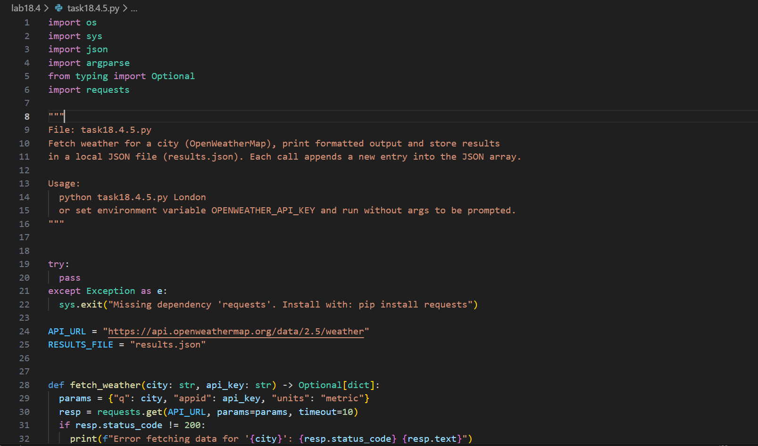
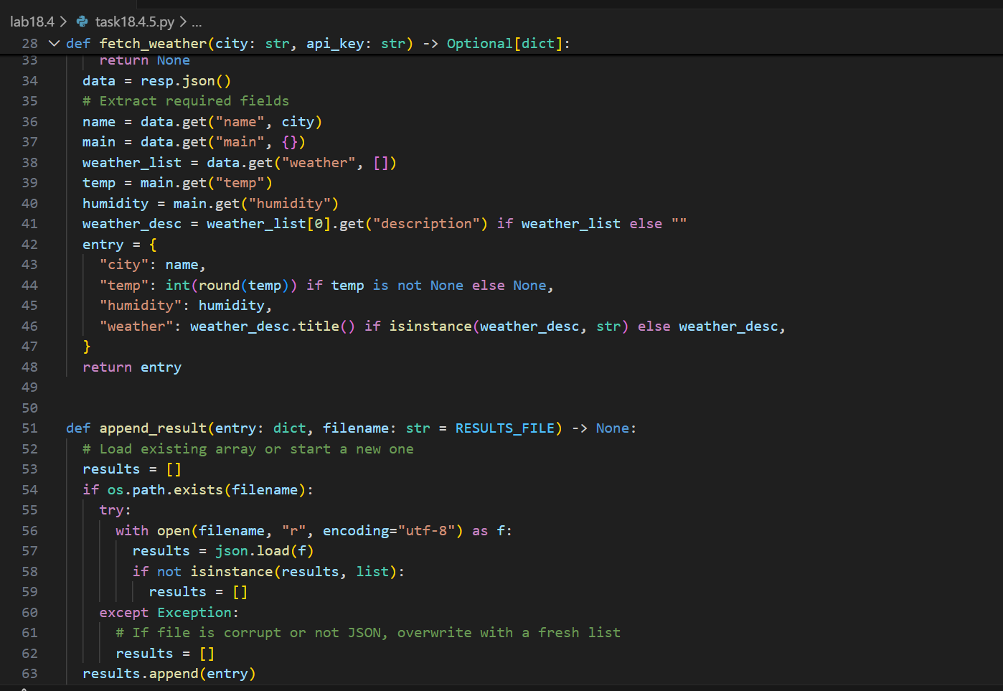
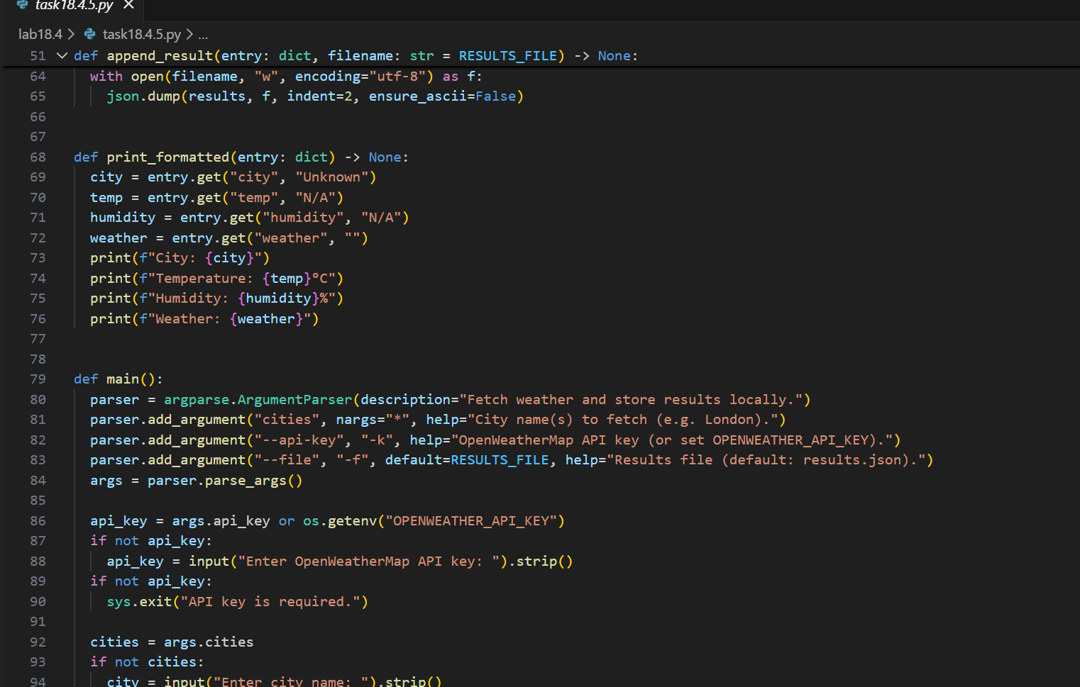
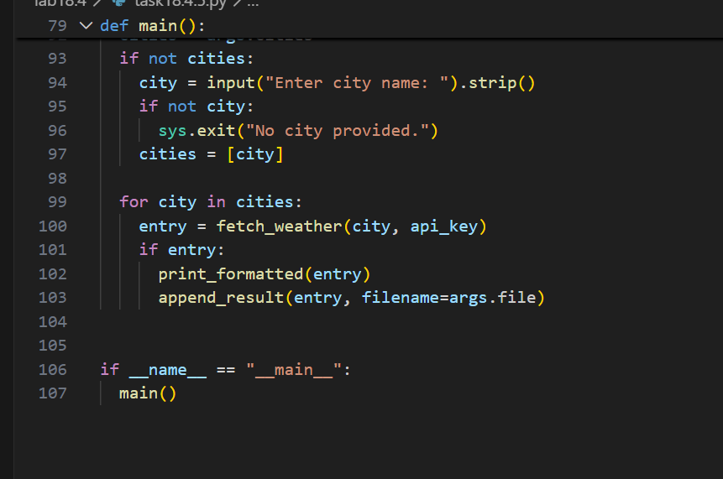
OUTPUT:

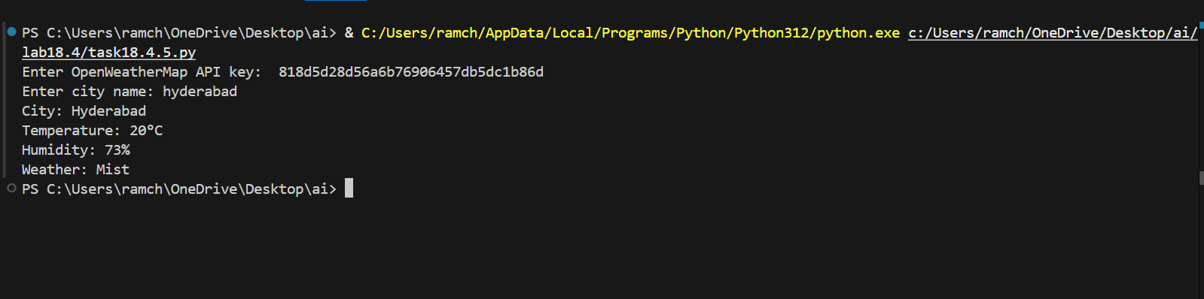
OBSERVATION:
This program fetches weather information for one or more cities using the OpenWeatherMap API.
It shows each city’s temperature, humidity, and weather description in a clean format.
Every time it runs, it also saves the results into a local JSON file, adding each new entry to the list.
The user can enter cities and API keys through command-line arguments or by typing them when prompted.
Overall, it provides an easy way to look up weather data and keep a growing record of all queries.

